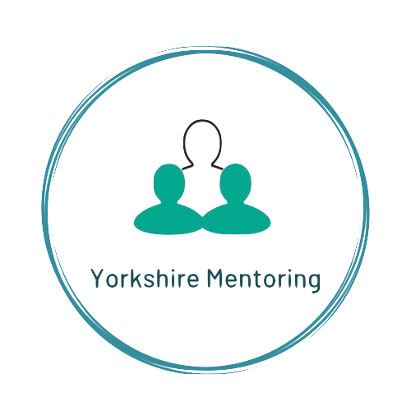
Mentoring for 11-18 year olds
Referral Form

Please complete all pages and return to: kirklees@yorkshirementoring.org.uk

Remember to Password Protect before you send for Data Protection.

To password protect click Review in the tool bar, click protect document icon
& type the password you have been provided by Yorkshire Mentoring & save

REFERRING ORGANISATION DETAILS

Referring Organisation
Name
Position
Telephone number
Email
In what capacity do you know the young person?
How long have/will you be working with the young person?

YOUNG PERSON DETAILS

Name
Address
Postcode
Young Person’s Phone Number
Any known learning needs?
Date of birth
Gender identified
Ethnicity
Any known medical conditions or allergies
PARENT/CARER DETAILS

Name
Relationship to young person
Address
Postcode
Parent/Carer Phone Number/s

EDUCATION DETAILS

Does the young person attend: | School/College/AP/Employment/Other (delete as applicable)
Year Group
Name of school/college/company/other
Name of link staff member
Telephone
Email
Current education/work attendance rate as percentage for previous term/last 6 weeks

REFERRAL CRITERIA

Applicants must be 11 - 18 years old. They must consent to seeing a mentor. They must either live, be educated or work in Kirklees area
We support young people who could be considered to be at risk of offending. Research indicates those most ‘at risk’ meet multiple risk factors from those detailed below. Applicants must meet at least two risk factors

Please put an ‘x’ against each risk factor relevant to the referral.

1 |  |  | Young people in or leaving care
2 |  |  | Young people excluded or at risk of exclusion from education
 |  |  | OR
 |  |  | Young people not in employment or training
3 |  |  | Young people displaying signs of anti–social, criminal behaviour or at risk of exploitation;
4 |  |  | Young people affected by drugs, crime and or alcohol directly or within their family
5 |  |  | Young people experiencing emotional problems such as bullying, bereavement, domestic
 |  |  | abuse or family issues, including a culture of offending within their family

REASONS FOR REFERRAL

What are the reasons for the referral?

Please complete reasons within the following FOUR areas.
In answering this question reference the risk factors you highlighted above, expanding each box as required.

Learning & Attainment

For example;
Improving positive values and beliefs, Increase aspirations and positive outcomes

Improve Self-confidence and efficacy including positive relationships

Parents/Carers & Home Life
What are the vulnerabilities
Wider Family, Peers & Environment
For example, is there a lack of Positive peer group; links to positive pastimes; and a need to develop new social interests

Other

If the young person has been cautioned or had interaction with the police or entered the Youth Justice System please detail here.

What do you hope might be achieved for this young person through mentoring?
Is there a target as the education provider you are wanting to achieve?

*YES Service referrals only - ASSESSMENT

If a referral is made to Yorkshire Mentoring via YES, all other support will run alongside the mentoring for young people under 18 years of age offered by Yorkshire Mentoring. Yorkshire Mentoring, will be in place for a period of up-to 4 Months meeting weekly or until Yorkshire Mentoring stop working with the young person through failed engagement.

Has any offer Early Help Offer been put in place? Yes/No (If YES then please complete information on this referral form)

If not, are there any reasons for this?
Is there a member of the YES team who you wish us to liaise with regarding any required meetings during the mentoring period? Yes/No
If not, why not?
Please detail all services known to be supporting young person (except school/AP/ college/employer already given).

Service | Contact | Phone | Email

DO YOU HAVE A CURRENT RISK ASSESMENT FOR THIS YOUNG PERSON? Yes/No
(Please attach)

ALTERNATIVE SERVICES

Yorkshire Mentoring – Community Reach Out is one of three services funded by Safer Kirklees & VRU to support young people at risk of offending - the other services being Wrong Look Wrong Time Wrong Place Knife Crime awareness workshops across Kirklees, and School Based Mentoring Support based in Kirklees.

Our programmes offers support to 11 to 18 year olds through a volunteer mentor, and some group activities connecting young people with other local projects where its identified.

Has the referred young person previously worked with Yorkshire Mentoring? Please delete Yes / No

If yes, please detail when and for how long:

YOUNG PERSON’S REASONS
Where possible, please support the young person referred to explain why they’d like to be mentored and what they would hope to gain:

I would like to be mentored because...

I have agreed to share the above personal information, including any offending behaviour history, with Yorkshire Mentoring and understand that in giving this information, it will be treated in the strictest confidence.

I understand what working with Yorkshire Mentoring will involve, and want to be mentored.

Signature of Young Person: Date:

Signature of Parent / Carer: Date:

Verbal agreement from young person, parent, carer is acceptable. If the referral is accepted a consent will be taken from to the parent / carer for community-based mentoring when met for introduction.
THANK YOU
We will contact the referrer on receiving the referral to confirm next steps

Please return completed forms to:
Kirklees@yorkshirementoring.org.uk
www.yorkshirementoring.org.uk
Remember to Password Protect before you send for Data Protection.

To password protect click Review in the tool bar, click protect document icon
& type the password you have been provided & save

